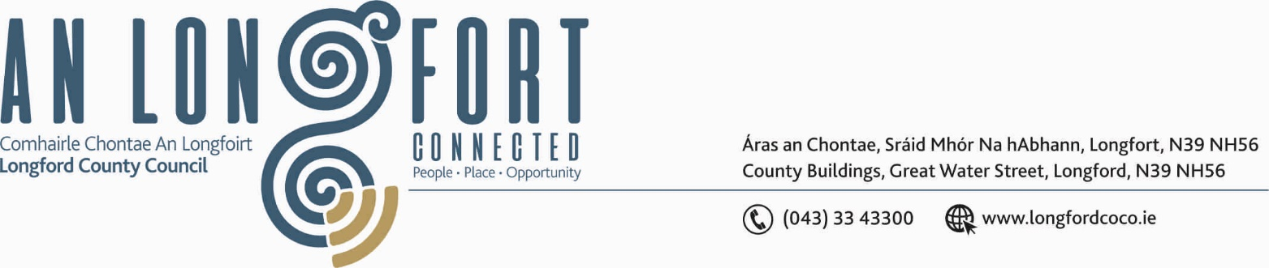

GRANARD MUNICIPAL DISTRICT

Please note meeting will be held in Longford Rugby Club and via Microsoft Teams.

18th November 2020.

To: Each Member of Granard Municipal District.

Dear Member,

You are requested to attend Meeting of Granard Municipal District to be held in
Longford Rugby Club on Tuesday, 24th November 2020 at 3.30 p.m.
to transact business, as set out on the Agenda hereunder.

Yours sincerely,
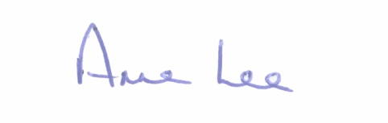

_______________
Anne Lee,
Meetings Administrator.

AGENDA

Prayer before meeting.

1. Confirmation of Minutes of the following Granard Municipal District Meetings -
(i) Committee MD Meeting held on the 22nd September 2020
(ii) September MD Meeting held on the 22nd September 2020.
(iii) Committee MD Meeting held on the 27th October 2020 (GMA)
(iv) 2021 GMA MD Meeting held on the 27th October.
- copies enclosed

2. Matters arising from Minutes.

3. Declaration of Interest by Members.

4. Management Report incorporating Area Engineer’s Progress Report
- enclosed.

5. Granard Public Art Features.

6. Special Projects / Members’ Discretionary Funds.

7. Community Grant Support Scheme 2020.

8. Keep Well Campaign.

9. Notices of Motions, submitted by Councillors, as listed hereunder –

Councillor Paraic Brady.

“I seek clarification on the Drainage Programme as there are two rivers - one in Drumlish and one in Ballinamuck that are causing flooding and need to be cleaned and also, that Longford County Council along with Leitrim County Council engage in drainage of the Black River as it is narrow in spots and some trees have fallen into parts of the river and are causing a dam and holding back water .There needs to be work carried out every year on this river and it should be a joint effort as land in Longford and Leitrim is getting flooded.”

“That all telecom poles and E.S.B. Poles that are replaced or put up new are set back off the edge of the road as some poles that were put up on the Cloone Road out of Drumlish are causing a serious hazard and are a danger to road users. I am looking for Telecom to come back and set these poles
at least .5 of a meter off the road.”
Councillor Turlough McGovern.

“I propose that Longford County Council move the Bottle Banks in Granard town to a more suitable place as they are causing illegal dumping and littering where they are located at present.”

“I call on Longford County Council to repair the county bridge at Ballywillan, which is in disrepair on both sides i.e .Longford and Cavan.”

Councillor Garry Murtagh.

“I wish to add the Lough Oughter/Lough Erne water system to the Drainage Scheme and log it with the Environmental Section. It was a combined effort between Longford, Leitrim & Cavan. Rivers were cleaned every three years with Cavan taking the lead. However, it hasn't been done since 2008 and the problems of flooding are becoming dangerously evident and also compounding the problems at Drumury Bridge.
I am hopeful through the support of Longford County Council and my colleagues, that former partnerships can be initiated for the betterment of the citizens living in the surrounding boundaries of the three Counties.”

“I call on Longford County Council to carry out restoration works at the junction historical known as the 4 white walls. This Junction is recorded on maps as the 4 white walls and has long been noted locally, nationally and internationally as a meeting place and focal point which is situated between
two provinces Ulster Co. Cavan & Leinster Co. Longford.”
“Low Cost Safety Scheme - Smear/Crott road extremely dangerous bend on the road where there has been a number of serious accidents and one fatality. There are serious concerns for safety at this point of the road.
Your support and that of my colleagues on this issue is in need of serious consideration.”



